Step 1. Login to your account at https://plus.fairfaxcounty.gov/. (Must be a registered user—click on one of the multiple highlighted Register for an Account links shown below to register.)

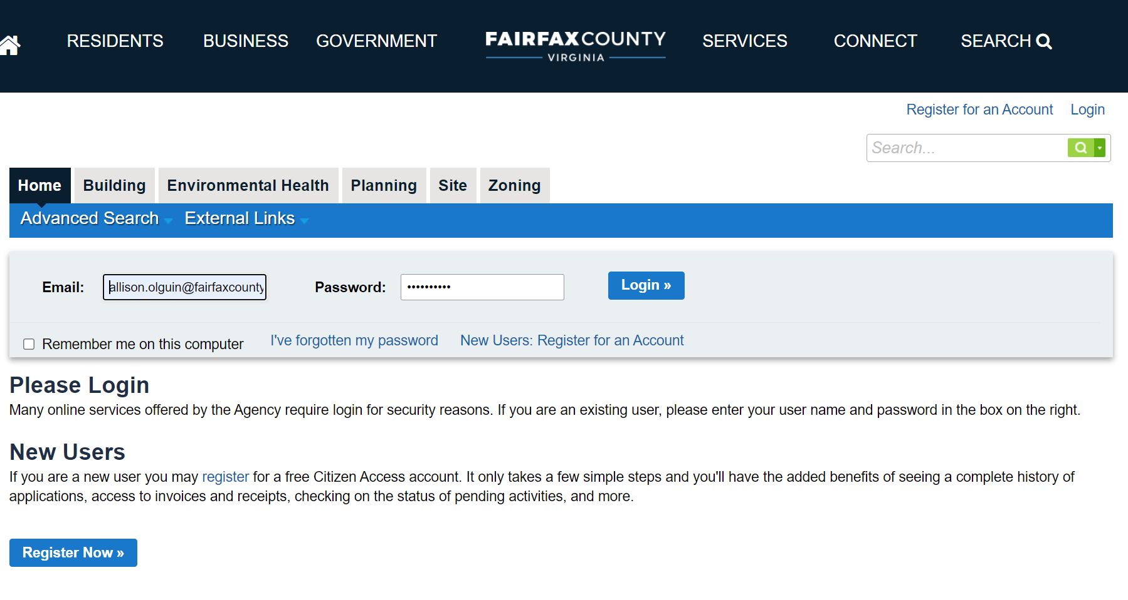
Step 2. Your Dashboard will load upon successful login. Click on Environmental Health to access Environmental Health applications.

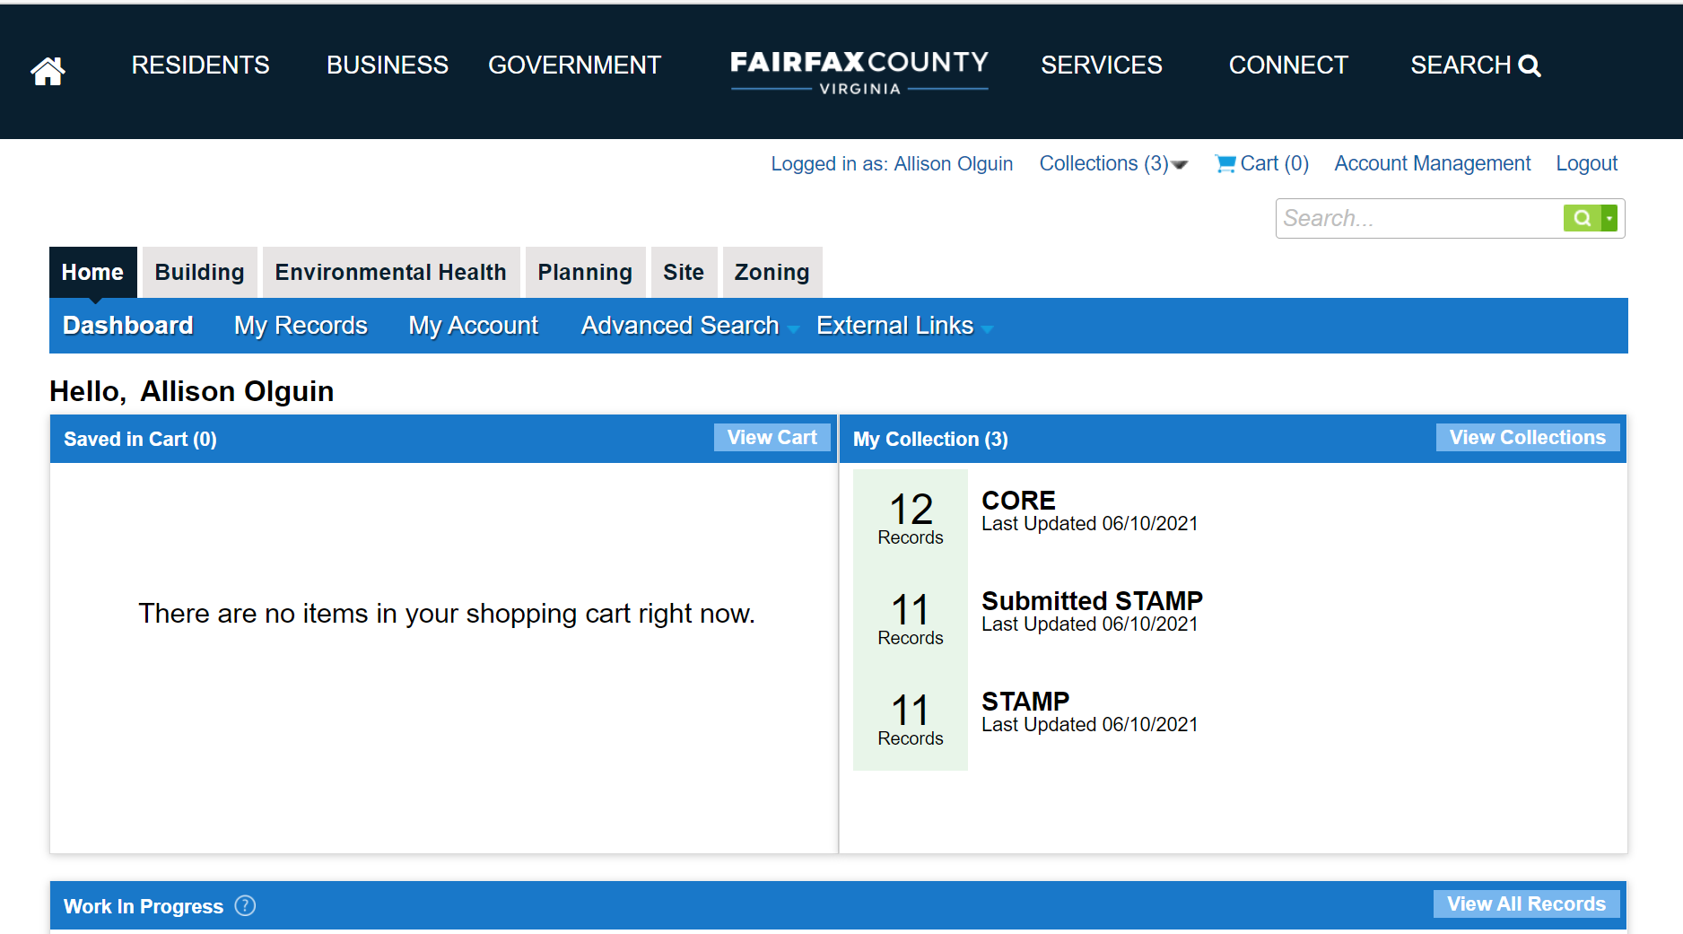
Step 3. Click on Create an Application.

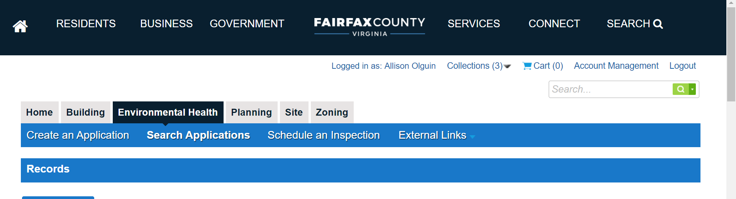

Step 4. Read and accept the terms by clicking on the box below, then click on Continue Application.

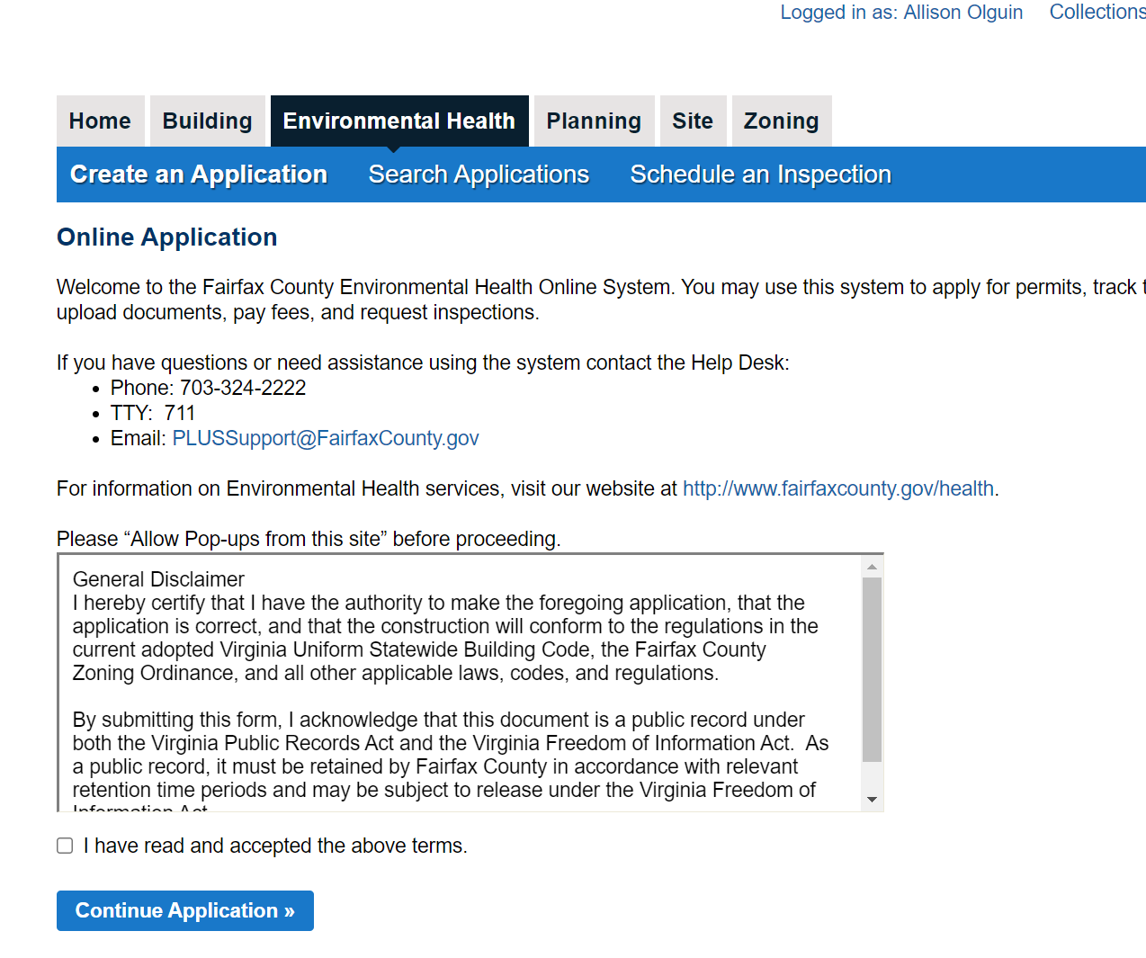

Step 5. Click on Temporary Event to expand the choices, then select Temporary Food Establishment Permit (TFEP).

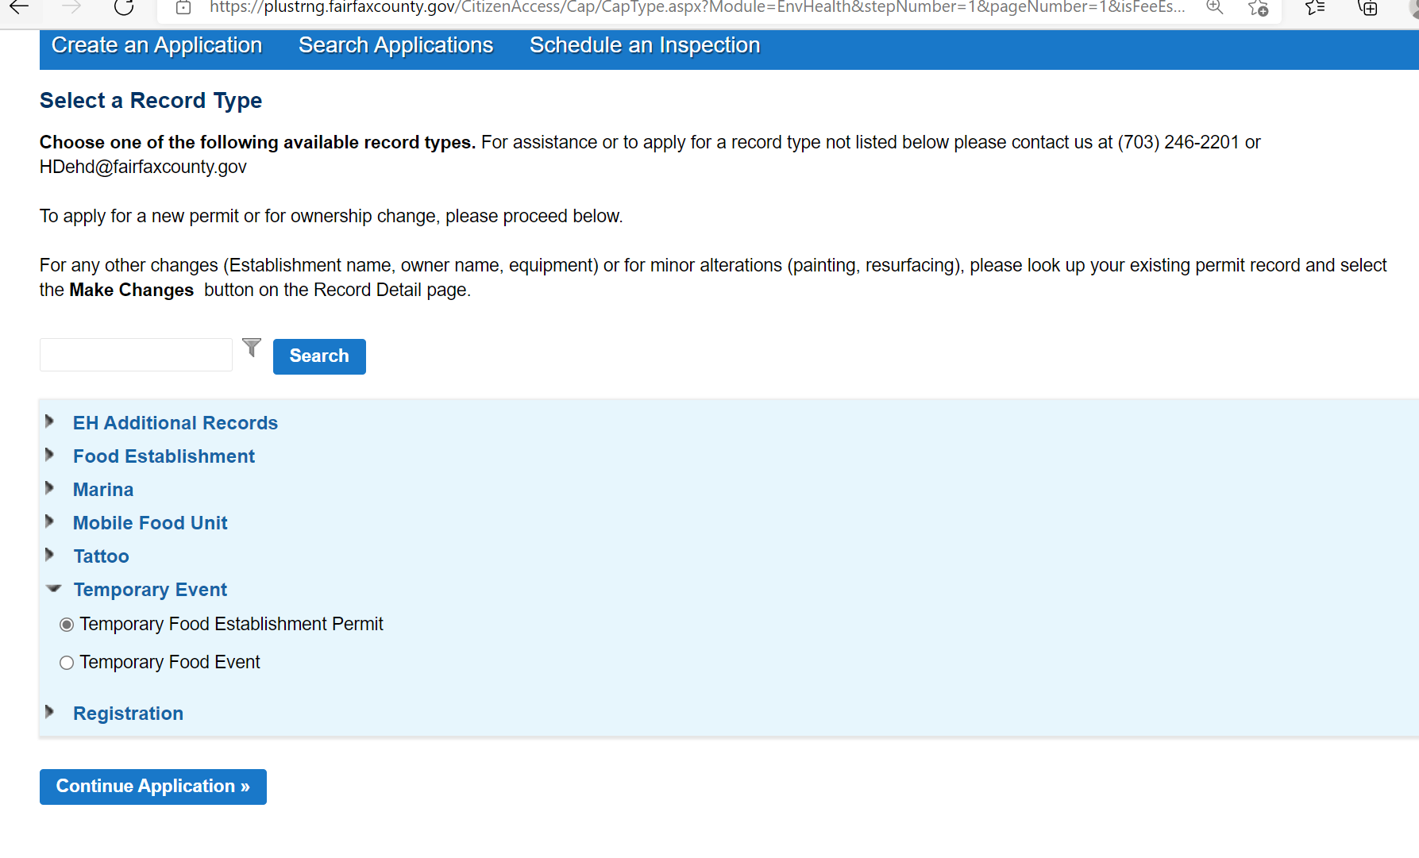
Step 6. Click on the dropdown “Event” menu to view list of open Temporary Events in the County. Select the appropriate event OR choose “Other” if the event you plan to participate in is not listed. If an existing Event is chosen the remaining fields will populate. If “Other” is selected you must manually enter the event details. Click on Continue Application to proceed.

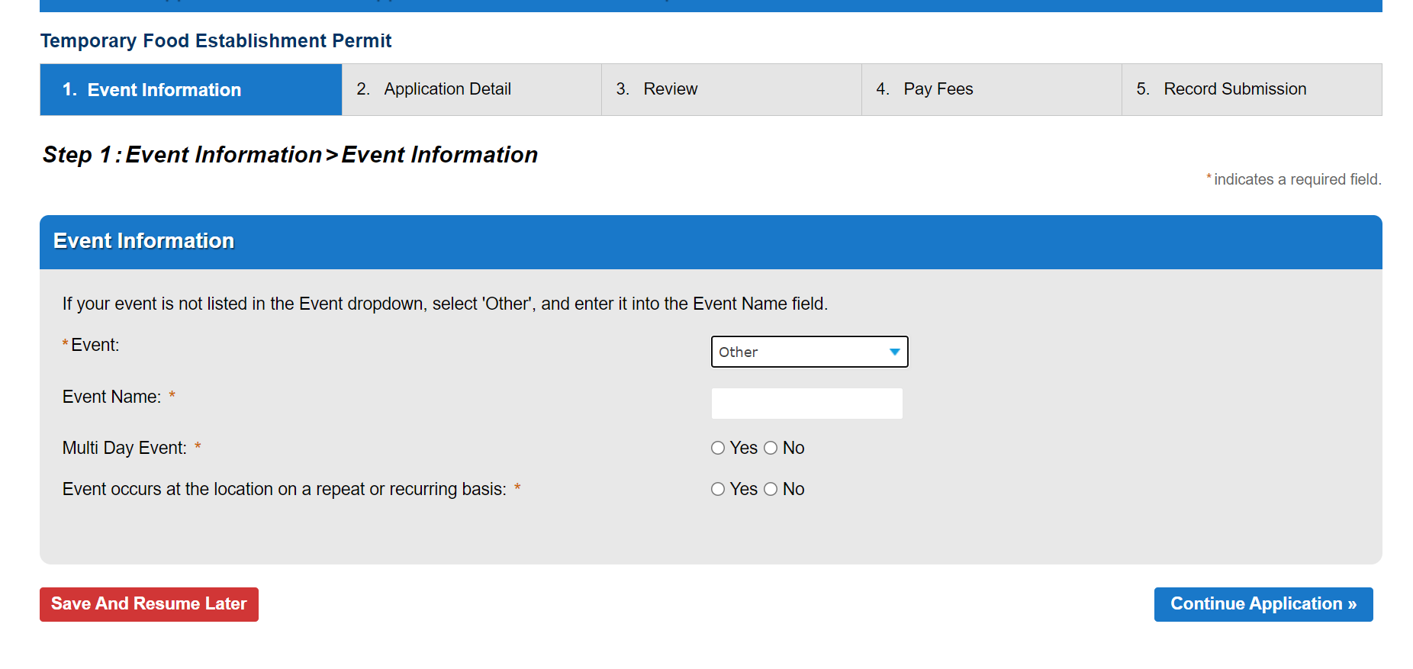

Step 7. If an existing event was selected from the list in the previous step, the address will populate. If “Other” was selected, the Street Number, Street Name, and Zip Code must be entered.

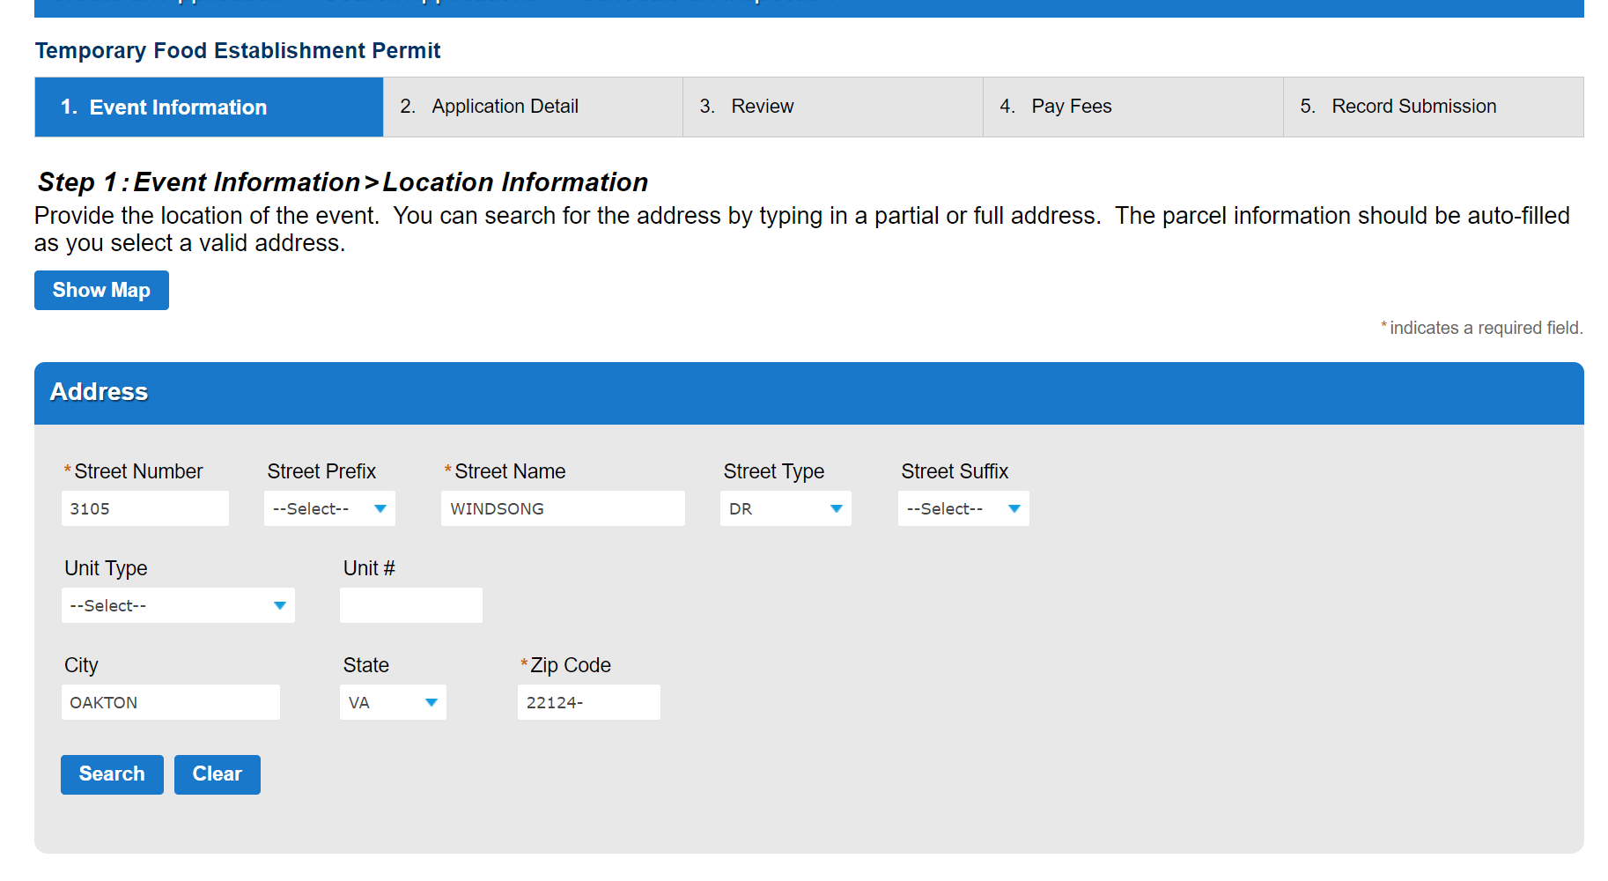

Step 8. Once a valid street address has been entered, the Parcel number will populate and cannot be edited. Click on Continue Application to proceed.

Step 9. If an existing Event was chosen from the dropdown list in Step 6, the Event Coordinator Contact information will populate. If “Other” was selected in Step 6, the Event Coordinator Contact information will have to be manually entered following the steps below.

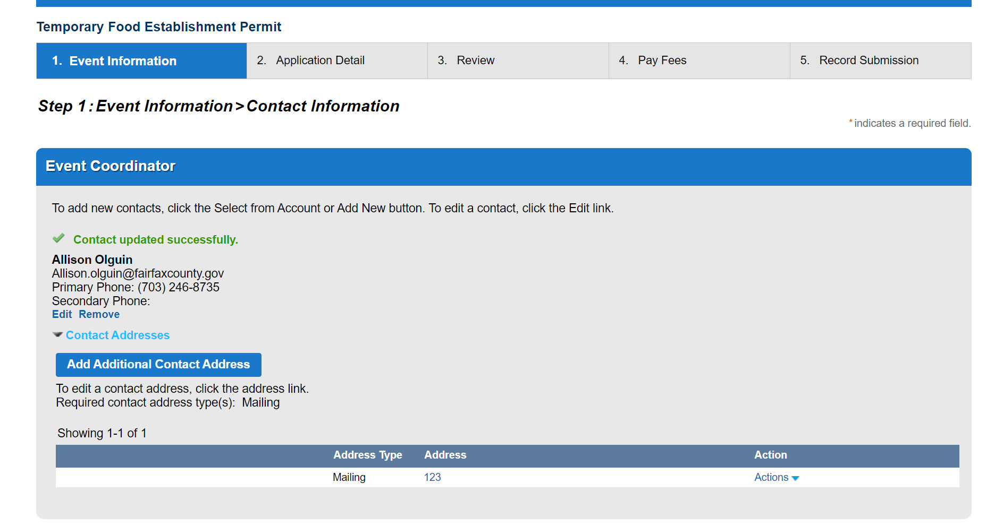

Step 10. Both the Applicant and Establishment Owner contact information must be entered. Click Select from Account to add the contact information associated with your customer account OR click on Add New to enter a different contact.

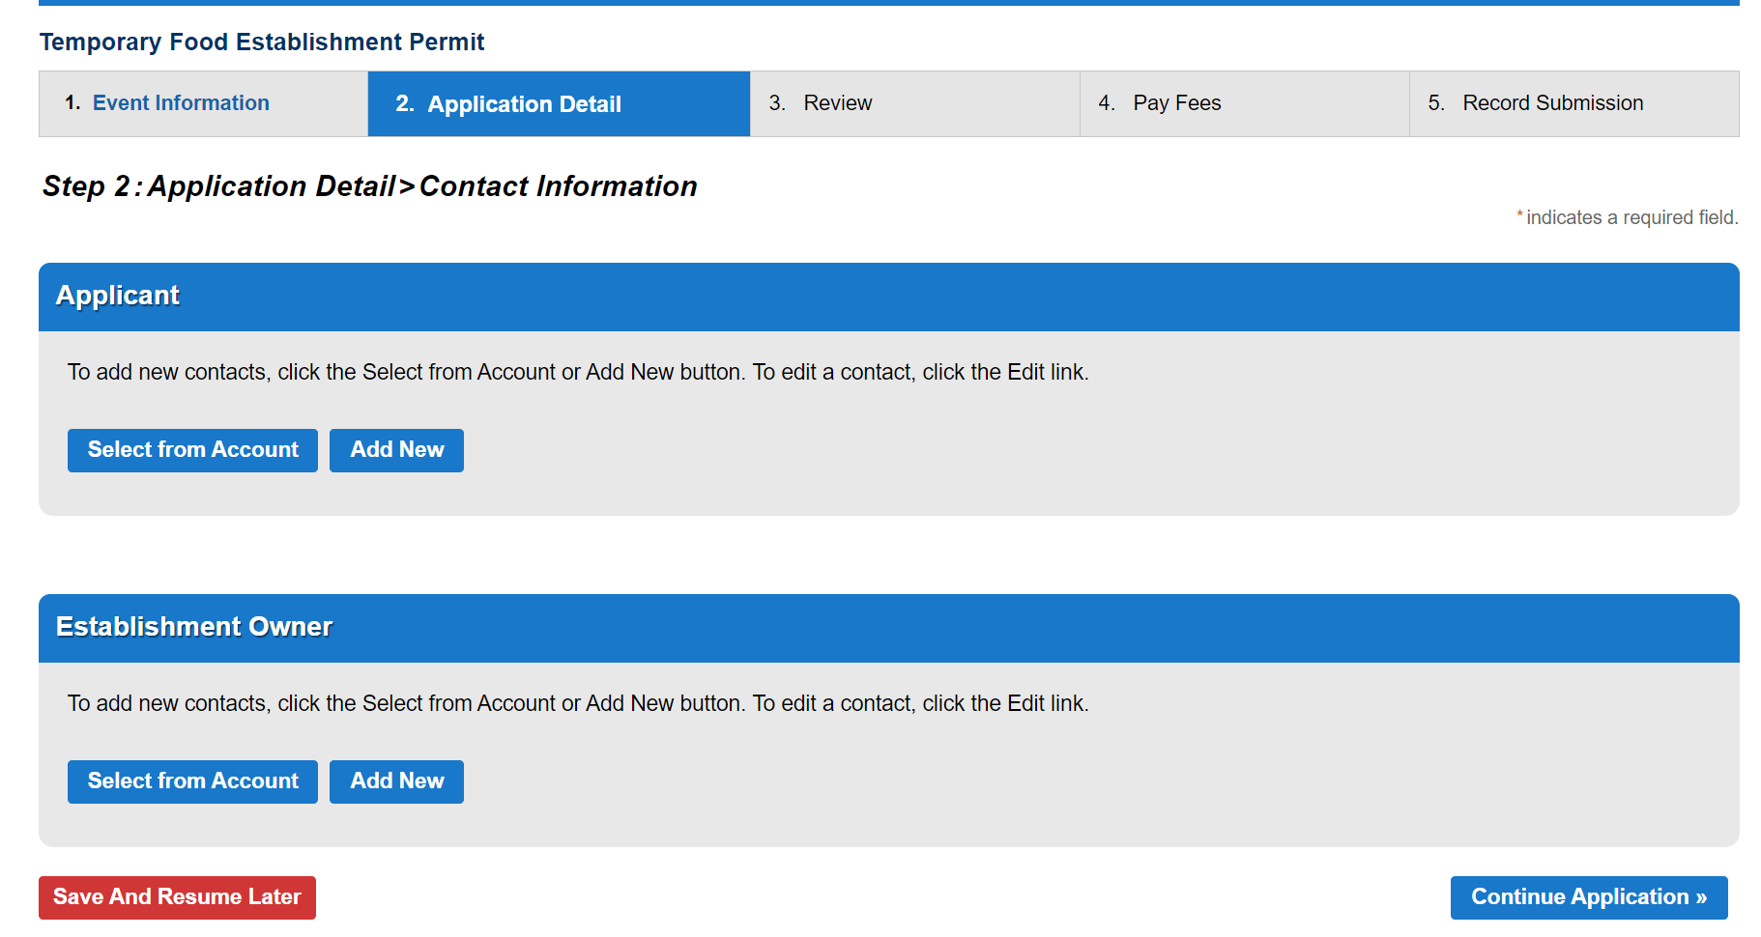

Step 11. When Add New is selected in Step 10, you must enter all fields with an asterisk.
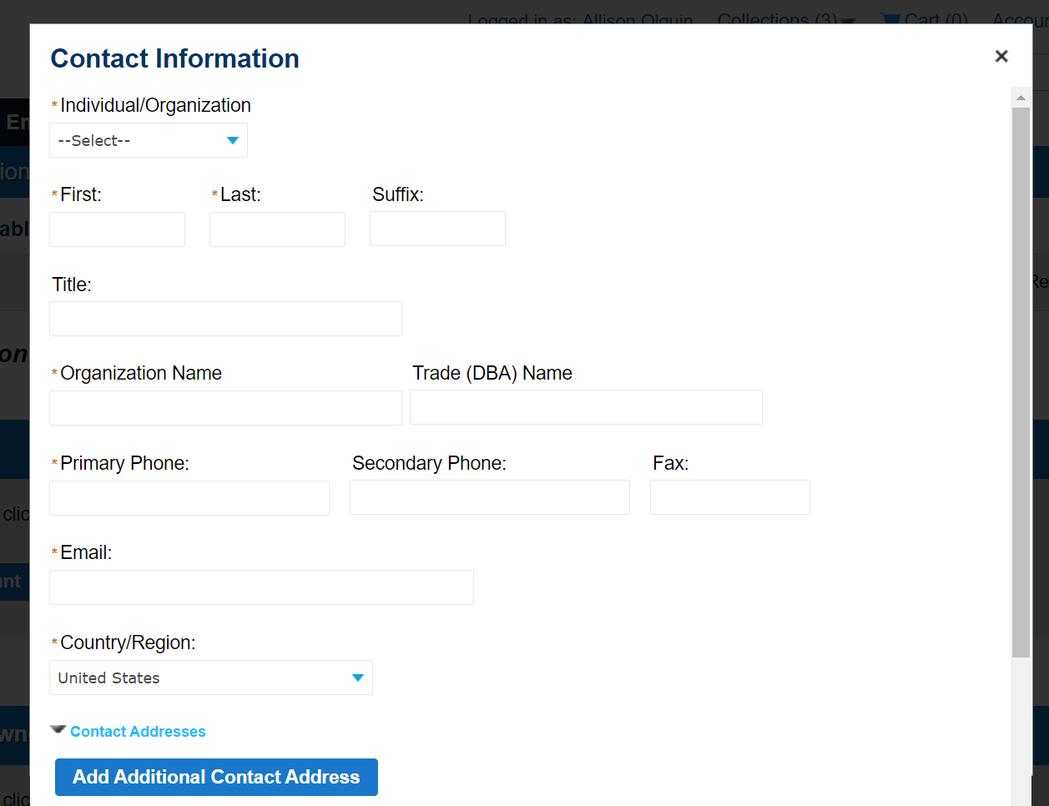

Step 12. Click on Add Additional Contact Address to add the mailing address (required). Enter all fields with an asterisk, including the Address Type dropdown. Click Save and Close to keep the entry.

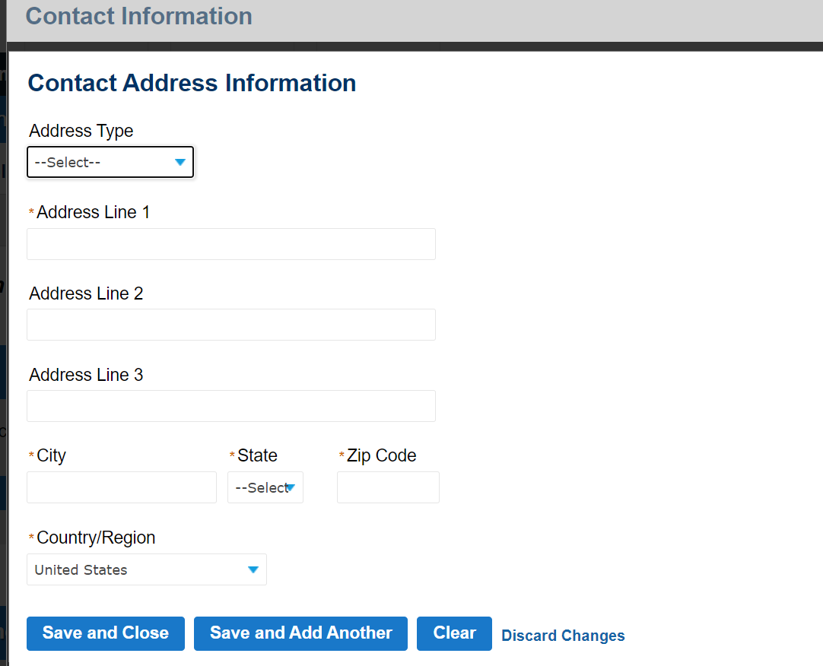

Step 13. Click Continue to save the Contact.

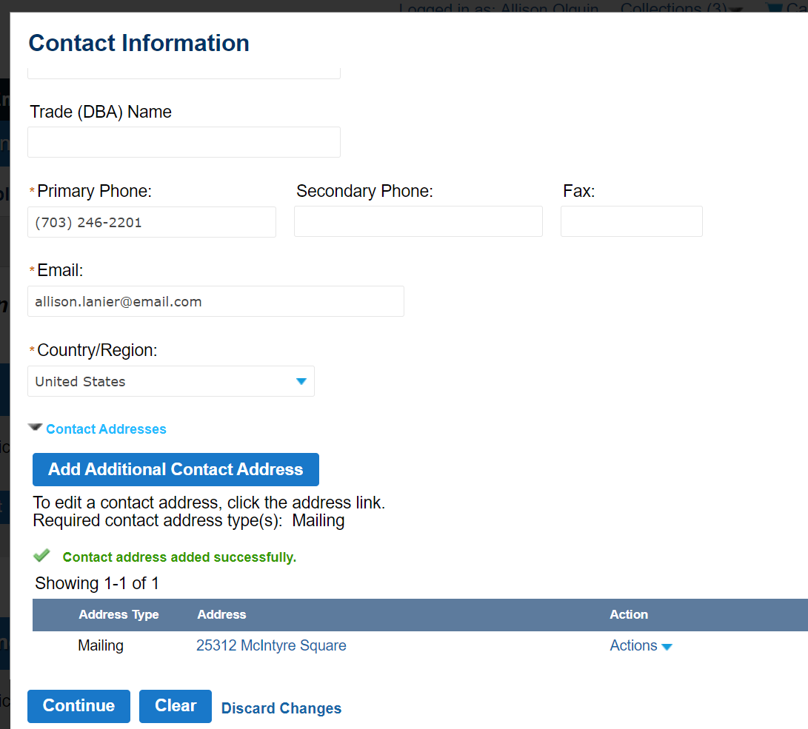

Step 14. Additional Contacts are optional and can be added following the same steps outlined above OR click on Continue Application to skip this step.

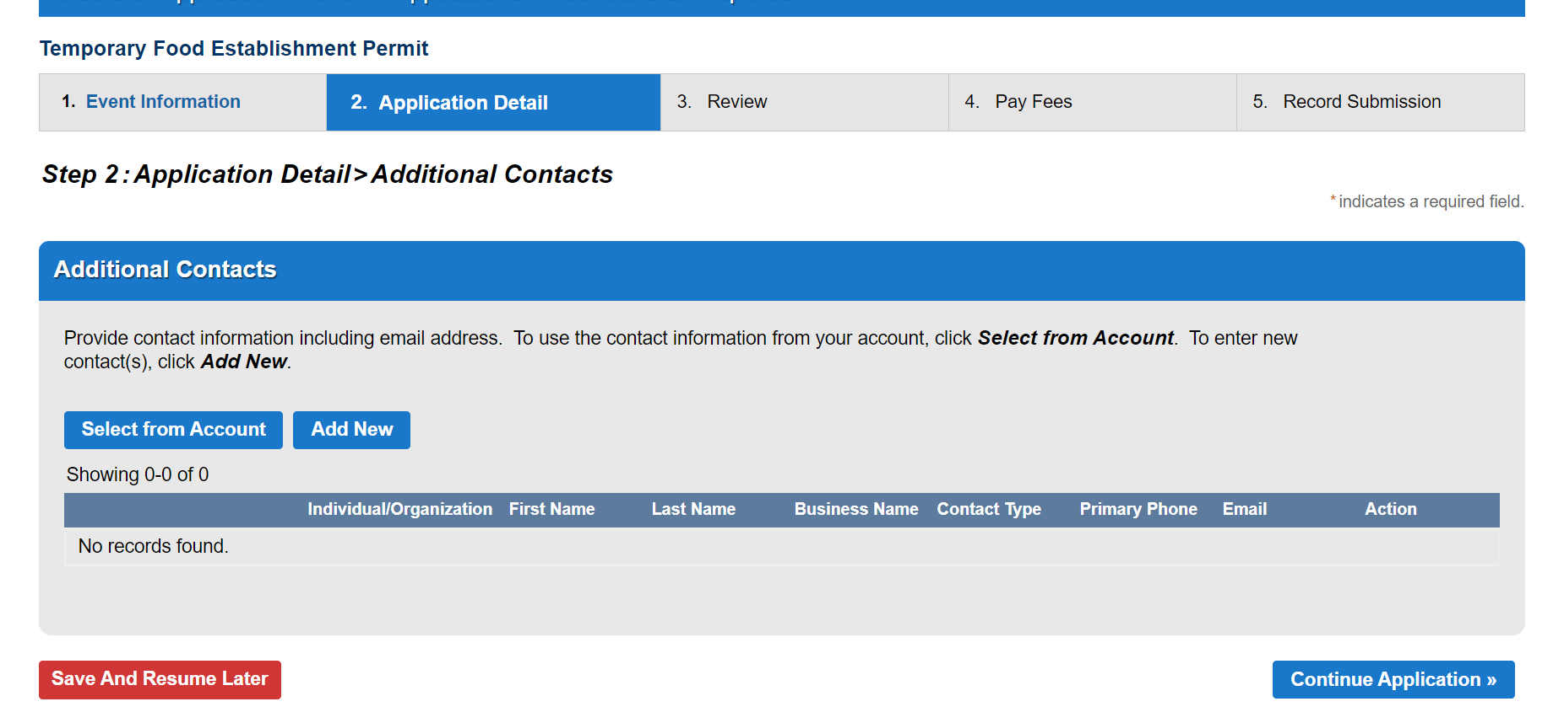

Step 15. Enter the name of the booth or mobile food unit in Name.

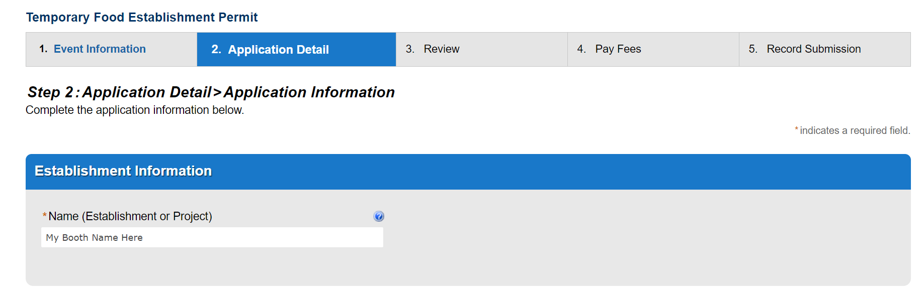

Step 16. Enter the required Vendor Information. Click Continue Application to proceed.

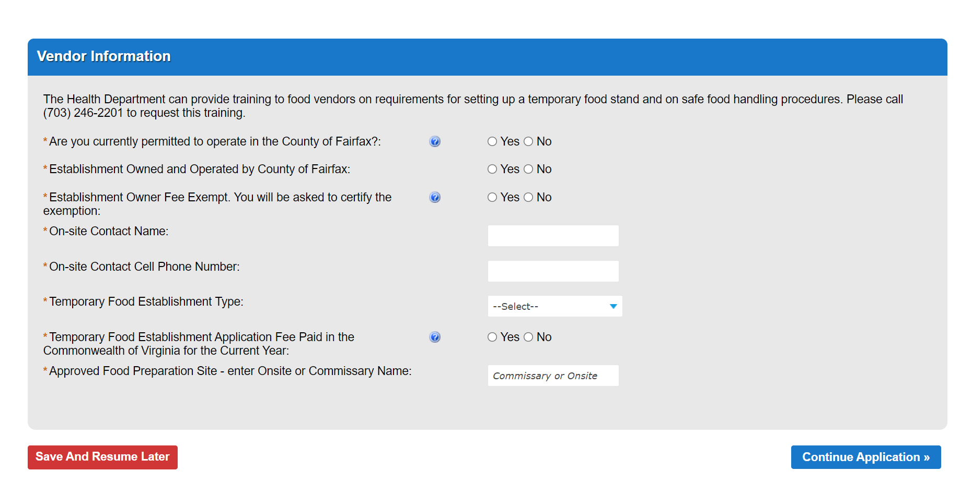

Step 17. Check off all Activity and Equipment Usage line items that apply to your proposed operation (#1 and #24 are required for all). Click Continue Application to proceed.

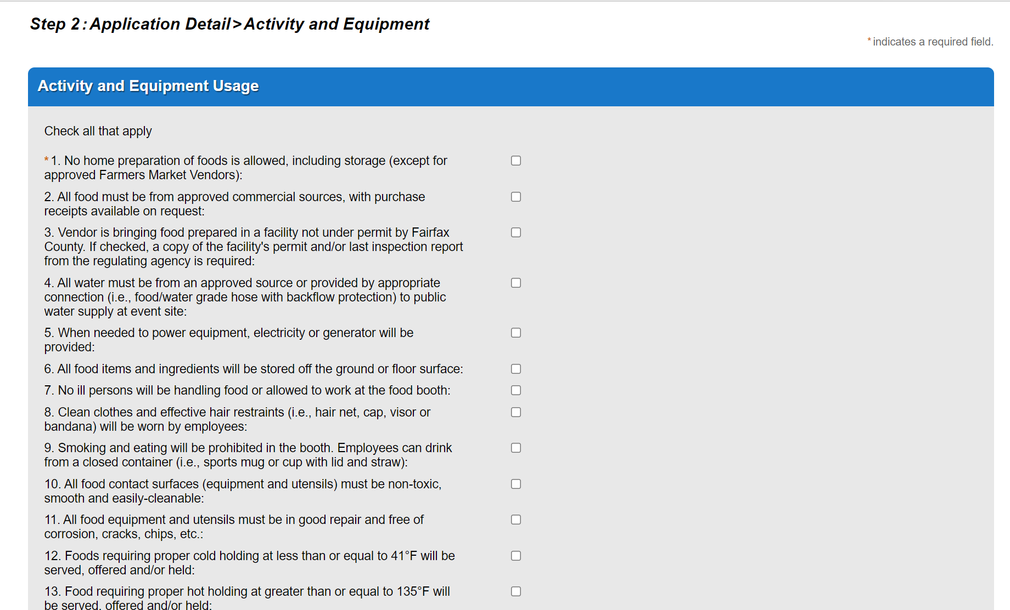
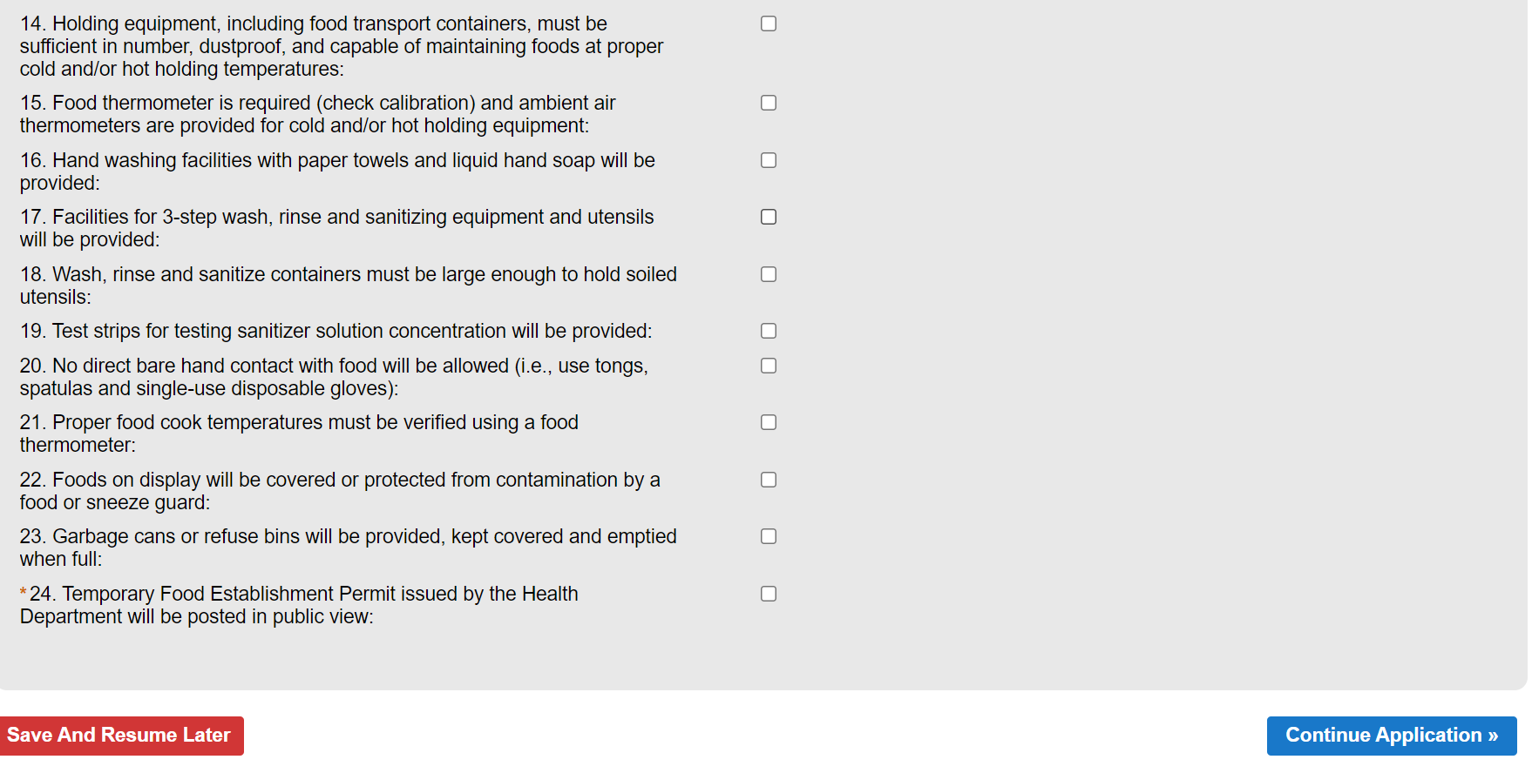

Step 18. Provide your planned menu, including the ingredients and where the item is to be prepared. Add a row for each individual menu item by clicking Add a Row, or click the dropdown arrow to add multiple rows at once.

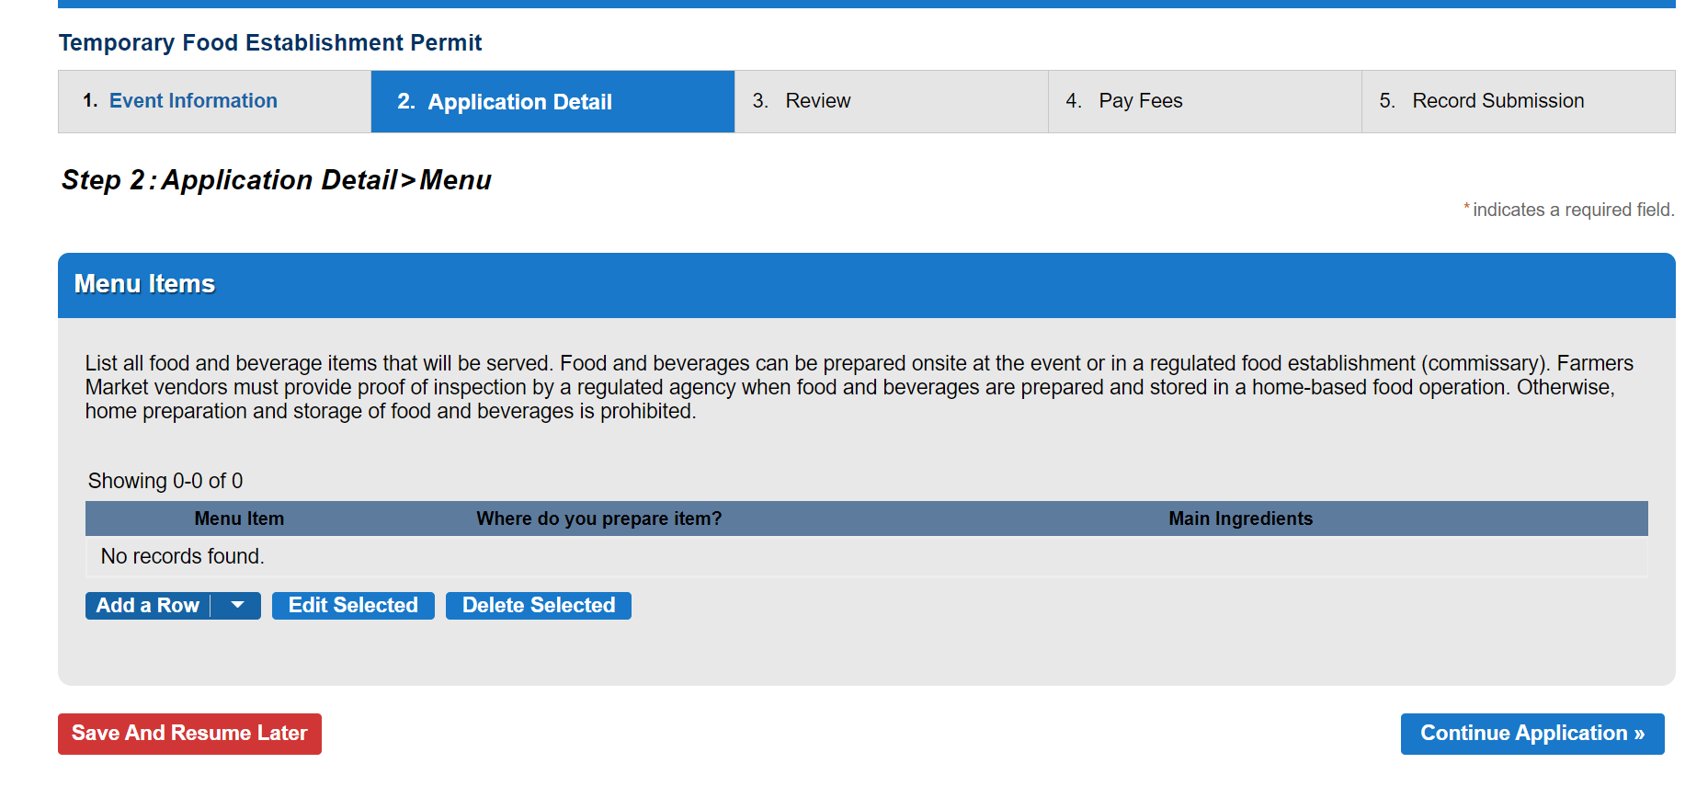

Step 19. Enter the menu item, where the item is prepared, and the main ingredients of the item. Click Submit to save.

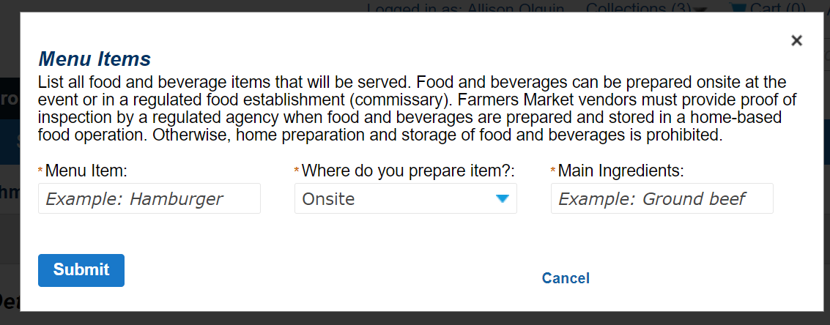

Step 20. Click Continue Application to proceed.

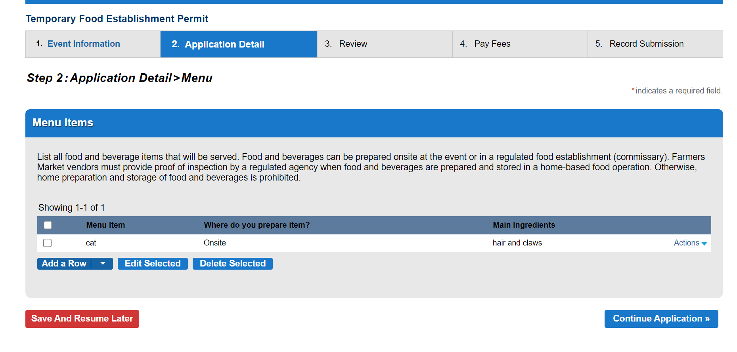

Step 21. Based on answers to the Vendor specific information, certain documents may be required to submit your application. To attach the required documents by clicking Add, then the select the file from your computer and click Open to attach it. Repeat steps for each document type listed. When all required document types are attached, click Continue Application.

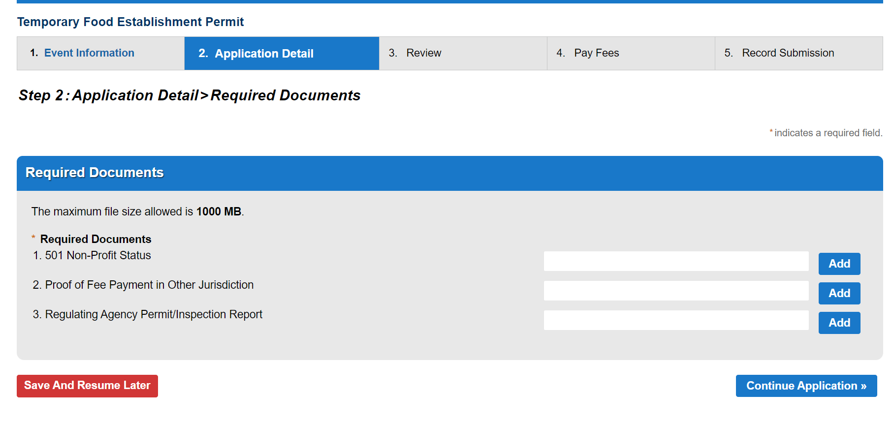

Step 22. Review your application details for accuracy. Click Edit to make changes to any field. When done reviewing, click Continue Application to submit. Save and Resume later will save your work and allow you to resume the application at a later time.

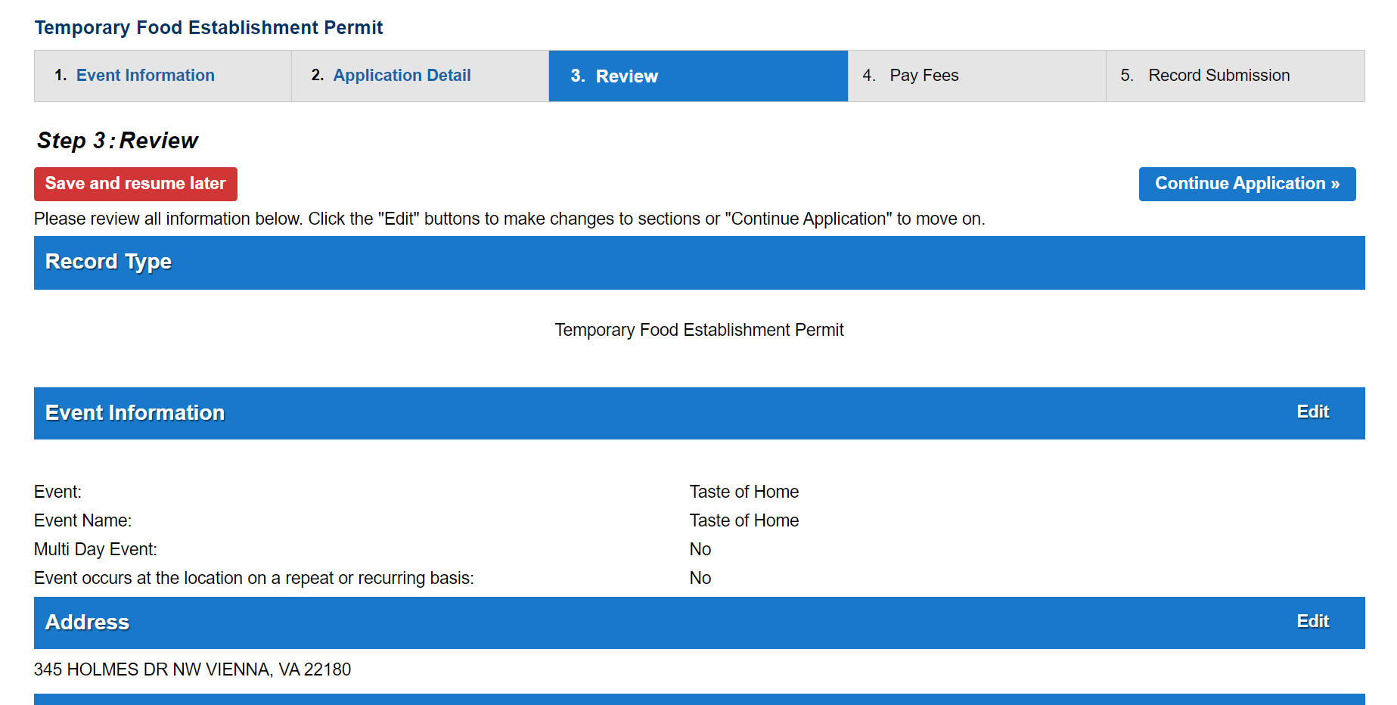

NOTE: You will see a confirmation message with your record number (HTFEP-XXXX-XXXXXX). Additionally, you will receive a confirmation email to Applicant and Establishment Owner contact emails provided. You will also receive emails notifications when the application is accepted, when a fee is invoiced, and when the permit is issued.

